DBS Guidance: Filtering rules for criminal record check certificates
The ‘Filtering rules for criminal record check certificates’ document is produced by the Disclosure and Barring Service. It is copied here under the Open Government Licence
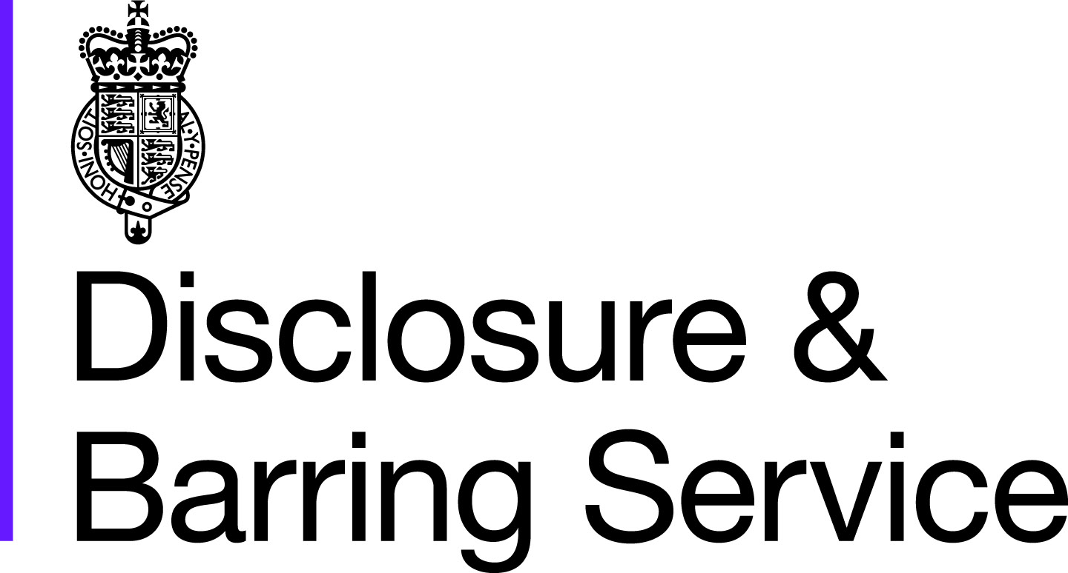
Filtering rules for criminal record check certificates

For those 18 or over at the time of the offence:
An adult conviction will be removed from a DBS criminal record certificate if:
• 11 years have elapsed since the date of conviction; and
• it is the person’s only offence, and
• it did not result in a custodial sentence.
Even then, it will only be removed if it does not appear on the list of offences relevant to safeguarding. If a person has more than one offence, then details of all their convictions will always be included.
An adult caution will be removed after 6 years have elapsed since the date of the caution – and if it does not appear on the list of offences relevant to safeguarding.
For those under 18 at the time of the offence:
• The same rules apply as for adult convictions, except that the elapsed time period is 5.5 years
• The same rules apply as for adult cautions, except that the elapsed time period is 2 years.

